

Faculty of Computer Applications
BCA Sem-1
(AY-2026-27)

Lab Book

Sub Code : 05BC3103
(Programming Practices : 1)

Roll No : | 92600527093
Full Name : | Priya Akbari

GitHub Link | https://github.com/Priya-312/BCA-1-PP-1--92600527093-Priya-Akbari

Sub.Faculty Name : Dr.Ashwin Dobariya
Index
Unit : 2
Program No | Definition
1. | Write a Program to Print "Hello World".
2. | Write a Program that takes 2 Values from user and Perform All Arithmetic Operation.
3. | Write a program that takes 3 values for Principle Amount, Rate of Interest and No. of Years and find out Simple Interest.
4. | Write a program that input value from user and find out Area of Circle.
5. | Write a program that input two values from user and find out Area of Rectangle.
6. | Write a program that input 3 values from user and find out its Average.
7. | Write a program to Calculate the Square and Cube of a number.
8. | Write a program Interchange the value of two numbers using third variable.
9. | Write a program Interchange the value of two numbers without using third variable.
10. | Write a program that input quantity, price, discount and display final amount.
(1) Write a Program to Print "Hello World".

Algorithm :

Step 1 : START
Step 2 : PRINT “Hello World”
Step 3 : STOP

Flowchart :

PRINT “Hello World”
STOP
START

Code :

#include<stdio.h>
#include<conio.h>

void main(){
clrscr();
printf("Hello World");
getch();
}

Output :

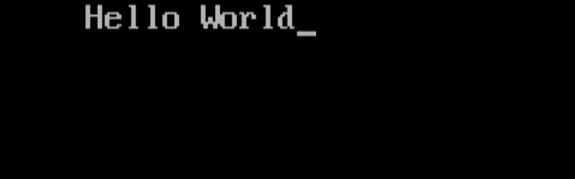

(2) Write a Program that takes 2 Values from user and Perform All Arithmetic Operation.
Algorithm :

Step 1 : START
Step 2 : DECLARE variables x=0.0, y=0.0, a, s, m, d
Step 3 : INPUT x,y
Step 4 : a = x + y
Step 5 : s = x – y
Step 6 : m = x * y
Step 7 : d = x / y
Step 8 : OUTPUT a, s, m, d
Step 9 : STOP

Flowchart :

OUTPUT a, s, m, d
INPUT x, y
d = x / y
m = x * y
s = x - y
a = x + y
DECLARE variables x=0.0, y=0.0, a, s, m, d
STOP
START

Code :

#include<stdio.h>
#include<conio.h>

void main()
{
float x,y;
clrscr();
printf("\n Enter Number 1: ");
scanf("%f",&x);
printf("\n Enter Number 2: ");
scanf("%f",&y);

printf(“Addition Is: %.2f \n”,x+y);
printf(“Subtraction Is: %.2f \n”,x-y);
printf(“Multiplication Is: %.2f \n”,x*y);
printf(“Division Is: %.2f \n”,x/y);

getch();

}

Output :
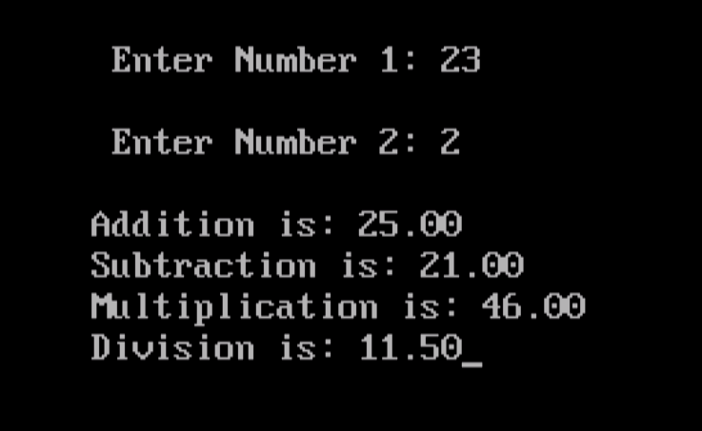
(3) Write a program that takes 3 values for Principle Amount, Rate of Interest and No. of Years and find out Simple Interest.

Algorithm :

Step 1 : START
Step 2 : DECLARE variables SI, P, R, T
Step 3 : INPUT P, R, T
Step 4 : SI = (P * R * T) / 100
Step 5 : PRINT SI
Step 6 : STOP

Flowchart :
STOP
PRINT SI
SI = (P * R * T) / 100
INPUT P, R, T
DECLARE SI, P, R, T
START

Code :

#include<stdio.h>
#include<conio.h>

void main(){
float SI,P,R,T;
clrscr();
printf("Enter Principal Amount: \n");
scanf("%f",&P);
printf("Enter Rate Of Interest: \n");
scanf("%f",&R);
printf("Enter Total Time: \n");
scanf("%f",&T);
SI=(P*R*T)/100;
printf("*************************\n");
printf("*Principal Amount=%.2f*\n",P);
printf("*Rate of Interest=%.2f *\n",R);
printf("*Time=%.2f *\n",T);
printf("*************************\n");
printf("*Simple Interest=%.2f *\n",SI);
printf("*************************");

getch();
}
Output :
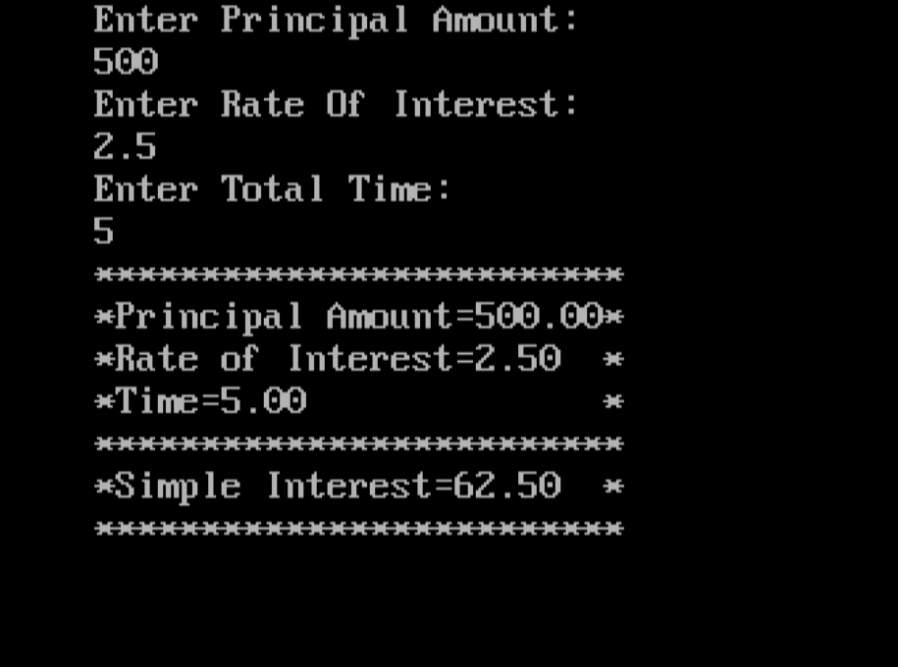
(4) Write a program that input value from user and find out Area of Circle.

Algorithm :

Step 1 : START
Step 2 : DECLARE variable r, area
Step 3 : INPUT r
Step 4 : area = 3.14 * r * r
Step 5 : PRINT area
Step 6 : STOP

Flowchart :
STOP
PRINT area
area = 3.14 * r * r
INPUT r
DECLARE variables r, area
START

Code :

#include<stdio.h>
#include<conio.h>

void main()
{
float Radius;
clrscr();
printf("Enter Radius Of Circle: \n");
scanf("%f",&Radius);
printf("The Area Of Circle is: %f",3.14*Radius*Radius);
getch();
}

Output :

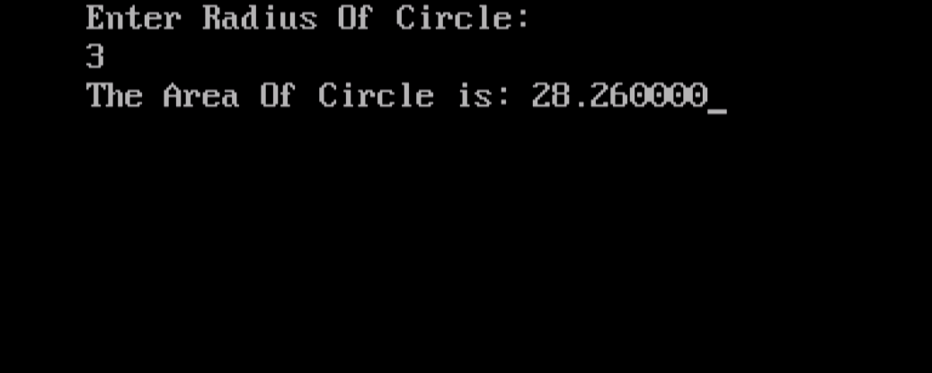
(5) Write a program that input two values from user and find out Area of Rectangle.

Algorithm :

Step 1 : START
Step 2 : DECLARE variable l, b, area
Step 3 : INPUT l, b
Step 4 : area = l * b
Step 5 : PRINT area
Step 6 : STOP

Flowchart :
DECLARE variables l, b, area
START

INPUT l, b

area = l * b

PRINT area

STOP

Code :

#include<stdio.h>
#include<conio.h>

void main()
{
float Length,Breadth;
clrscr();
printf("Enter Length Of Rectangle: \n");
scanf("%f",&Length);
printf("Enter Breadth Of Rectangle: \n");
scanf("%f",&Breadth);
printf("The Area Of Rectangle is: %f",Length*Breadth);
getch();
}

Output :

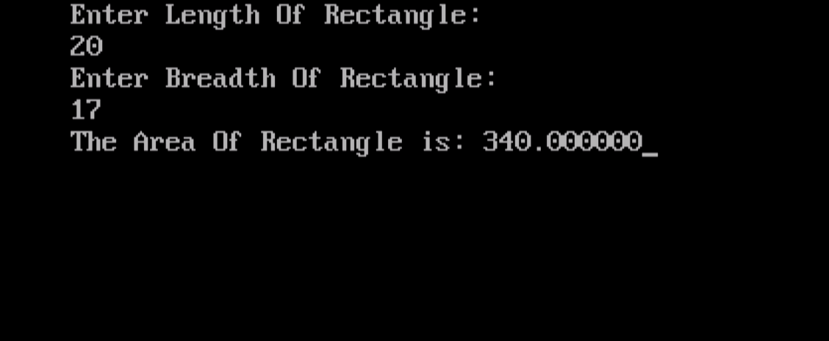

(6) Write a program that input 3 values from user and find out its Average.

Algorithm :

Step 1 : START
Step 2 : DECLARE variables x, y, z, avg
Step 3 : INPUT x, y, z
Step 4 : avg = (x + y + z) / 3
Step 5 : PRINT avg
Step 6 : STOP

Flowchart :

STOP
PRINT avg
avg = (x + y + z) / 3
INPUT x, y, z
DECLARE variables x, y, z, avg
START

Code :

#include<stdio.h>
#include<conio.h>

void main()
{
int x,y,z;
clrscr();
printf("\n Enter Number 1: ");
scanf("%d",&x);
printf("\n Enter Number 2: ");
scanf("%d",&y);
printf("\n Enter Number 3: ");
scanf("%d",&z);
printf("\n Average is: %d ",(x+y+z)/3);
getch();

}
Output :

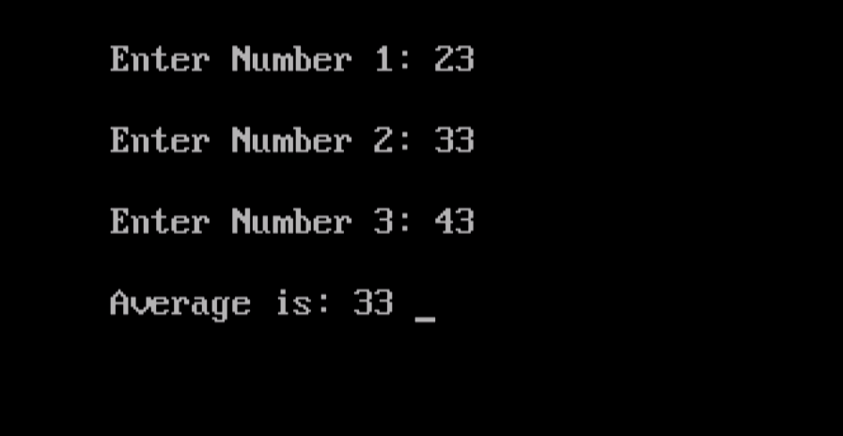

(7) Write a program to Calculate the Square and Cube of a number.

Algorithm :

Step 1 : START
Step 2 : DECLARE variables n, sqr, cube
Step 3 : INPUT n
Step 4 : sqr = n * n
Step 5 : cube = n* n* n
Step 6 : OUTPUT sqr, cube
Step 7 : STOP

Flowchart :

cube = n * n * n
STOP
PRINT sqr, cube
sqr = n * n
INPUT n
DECLARE variables n, sqr, cube
START

Code :

#include<stdio.h>
#include<conio.h>

void main()
{
int n;
clrscr();
printf("\n Enter Number: ");
scanf("%d",&n);
printf("\n Square is: %d",n*n);
printf("\n Cube is: %d",n*n*n);
getch();

}
Output :

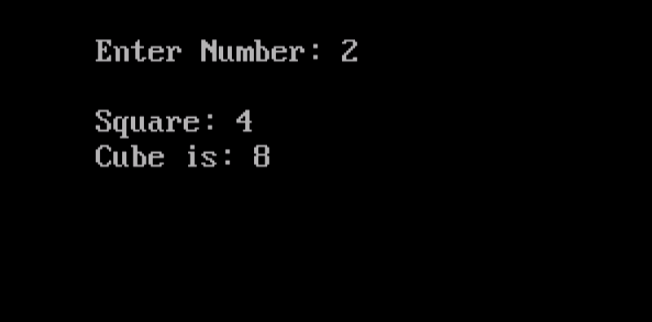
(8) Write a program Interchange the value of two numbers using third variable.

Algorithm :

Step 1 : START
Step 2 : DECLARE variables temp, x, y
Step 3 : INPUT x, y
Step 4 : temp = x
Step 5 : x = y
Step 6 : y = temp
Step 7 : PRINT x, y
Step 8 : STOP

Flowchart :
y = temp
x = y
STOP
PRINT x, y
temp = x
INPUT x, y
DECLARE variables temp, x, y
START

Code :

#include<stdio.h>
#include<conio.h>

void main()
{
int temp,x,y;
clrscr();
printf("\n Enter Number 1: ");
scanf("%d",&x);
printf("\n Enter Number 2: ");
scanf("%d",&y);
temp=x;
x=y;
y=temp;
printf("\nNew Number 1: %d",x);
printf("\nNew Number 2: %d",y);
getch();

}
Output :

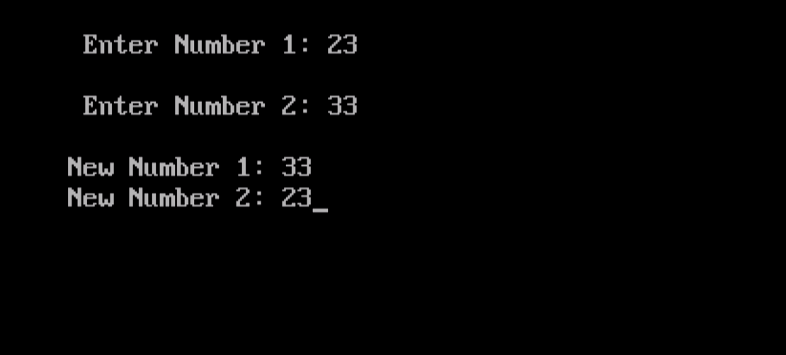

(9) Write a program Interchange the value of two numbers without using third variable.

Algorithm :
Step 1 : START
Step 2 : DECLARE variables x, y
Step 3 : INPUT x, y
Step 4 : x = x + y
Step 5 : y = x - y
Step 6 : x = x - y
Step 7 : PRINT x, y
Step 8 : STOP

Flowchart :

y = x - y
STOP
x = x + y
INPUT x, y
DECLARE variables x, y
START
x = x - y

PRINT x, y

Code :

#include<stdio.h>
#include<conio.h>

void main()
{
int x,y;
clrscr();
printf("\n Enter Number 1: ");
scanf("%d",&x);
printf("\n Enter Number 2: ");
scanf("%d",&y);
x=x+y;
y=x-y;
x=x-y;
printf("\nNew Number 1: %d",x);
printf("\nNew Number 2: %d",y);
getch();

}
Output :



(10) Write a program that input quantity, price, discount and display final amount.

Algorithm :

Step 1 : START
Step 2 : DECLARE variables q, pr, disc, f_amt
Step 3 : INPUT q, pr, disc
Step 4 : f_amt = q * pr – ((q * pr * disc) / 100)
Step 5 : OUTPUT f_amt
Step 6 : STOP

Flowchart :
STOP
PRINT f_amt
INPUT q, pr, disc
START

DECLARE variables q, pr, disc, f_amt

f_amt = q * pr – ((q * pr * disc) / 100)

Code :

#include<stdio.h>
#include<conio.h>

void main(){

float Input_quantity,Price,Discount,Final_Amount;
clrscr();
printf("Enter Quantity of Items: \n");
scanf("%f",&Input_quantity);
printf("Enter Price Of Item: \n");
scanf("%f",&Price);
printf("Enter Discount: \n");
scanf("%f",&Discount);
Final_Amount = Input_quantity*Price-((Input_quantity*Price*Discount)/100);
printf("The Final Amount Is: %.2f",Final_Amount);
getch();
}

Output :

